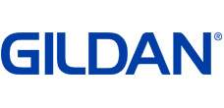
Gildan Adult 5.3 oz. Men’sT-Shirt G500
Features:
- 100% preshrunk cotton; Ash Grey is 99/1; Sport Grey is 90/10
- Seamless rib at neck
- Taped shoulder-to-shoulder
- Double-needle stitching throughout;
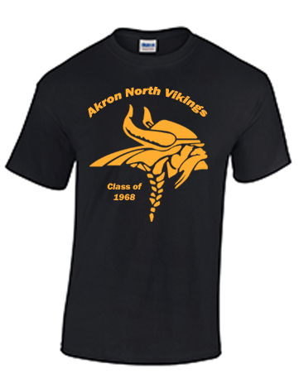
Product Specifications

 | S | M | L | XL | 2XL | 3XL | 4XL |  | 5XL | - | -
BODY LENGTH | 28 | 29 | 30 | 31 | 32 | 33 | 34 |  | 35 | - | -
BODY WIDTH | 18 | 20 | 22 | 24 | 26 | 28 | 30 |  | 32 | - | -
FULL BODY LENGTH | 28 | 29 | 30 | 31 | 32 | 33 | 34 |  | 35 | - | -
SLEEVE LENGTH | 15.62 | 17 | 18.5 | 20 | 21.5 | 22.87 | 2  4.25 |  | 25.38 | - | -
Pricing sizes S-XL with printing- $8.00/ea.
Pricing size 2XL with printing- $9.00/ea.
Pricing size 3XL with printing- $10.00/ea.
Pricing size 4XL with printing- $10.00/ea.
Pricing size 5XL with printing- $10.00/ea.

Gildan G540
Gildan Adult 5.3 oz. Long-Sleeve T-Shirt
Features:
- 100% preshrunk cotton
- double-needle stitching throughout
- seamless rib at neck
- taped shoulder-to-shoulder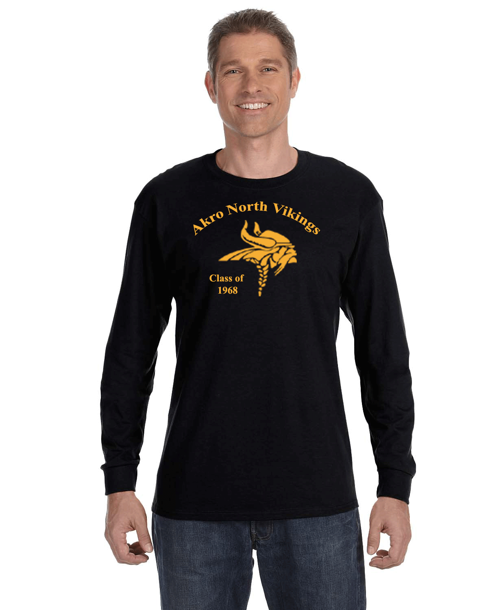
Product Specifications

 | S | M | L | XL | 2XL | 3XL | - | - | - | -
BODY WIDTH | 18 | 20 | 22 | 24 | 26 | 28 | - | - | - | -
FULL BODY LENGTH | 28 | 29 | 30 | 31 | 32 | 33 | - | - | - | -
SLEEVE LENGTH | 33.5 | 35 | 36.5 | 38 | 39.5 | 39.5 | - | - | - | -
WAIST WIDTH | 28 | 29 | 30 | 31 | 32 | 33 | - | - | - | -
WIDTH | 18 | 20 | 22 | 24 | 26 | 28 | - | - | - | -
Pricing sizes S-XL with printing- $10.00/ea.
Pricing 2XL with printing- $11.00/ea.
Pricing 3XlL with printing- $12.00

