Ladies Heavy Cotton Tees
100% preshrunk 5.3 oz Cotton
- double-needle stitching throughout; seamless rib at neck
- feminine ½" rib mid scoop neck; side seamed with slightly tapered Missy fit
- cap sleeves for comfort; taped shoulder-to-shoulder
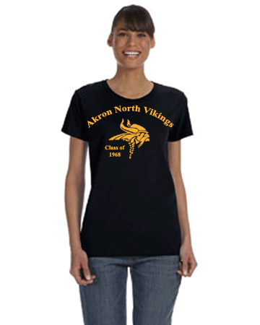

Product Specifications

 | S | M | L | XL | 2XL | 3XL | - | - | - | -
BODY LENGTH | 25.5 | 26 | 27 | 28 | 28.5 | 29 | - | - | - | -
BODY WIDTH | 17.25 | 19.25 | 21.25 | 23.25 | 25.25 | 27.25 | - | - | - | -
FULL BODY LENGTH | 25.5 | 26 | 27 | 28 | 28.5 | 29 | - | - | - | -
SLEEVE LENGTH | 13.25 | 14 | 14.75 | 15.75 | 16.75 | 17.5 | - | - | - | -

Pricing sizes S-XL with printing- $8.00/ea.
Pricing size 2XL with printing- $9.00
Pricing size 3XL with printing- $10.00/ea.

Gildan Ladies' 5.3 oz. Long-Sleeve 100% preshrunk 5.3 oz Cotton
- double-needle stitching throughout
- seamless rib at neck
- taped shoulder-to-shoulder
- seamless double-needle collar; double-needle sleeve and bottom hem
- taped neck; side seams with slightly tapered Missy fit
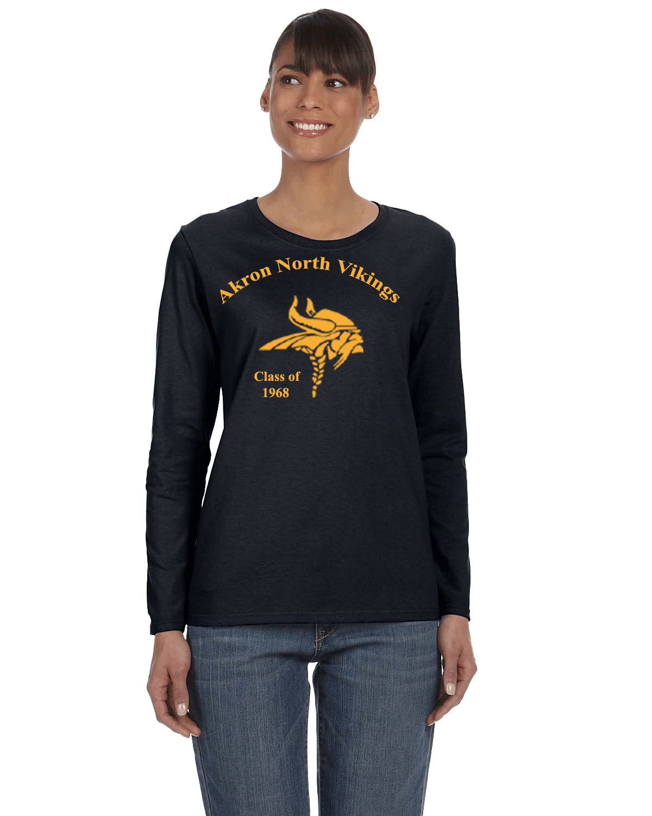

Product Specifications

 | S | M | L | XL | 2XL | 3XL | - | - | - | -
BODY LENGTH | 25.5 | 26 | 27 | 28 | 28.5 | 29 | - | - | - | -
BODY WIDTH | 17.25 | 19.25 | 21.25 | 23.25 | 25.25 | 27.25 | - | - | - | -
SLEEVE LENGTH | 30 | 30.5 | 31.5 | 32.5 | 33.5 | 34.5 | -

Pricing sizes S-XL with printing- $10.00/ea.
Pricing size 2XL with printing- $11.00/ea.
Pricing size 3XL with printing- $12.00/ea.

